Walking through Shanshui is an interactive installation attempt to reconstruct the experiment of traveling in mountain and water with traditional Chinese painting. By using a simplified point tracking model, the installation can track the portions of the people in a particular area and provide the traces instantly. Based on the traces, the AI system will generate a translation into the Shanshui painting (Computer Through Shanshui).

This work was created by Aven Le Zhou, who is an artist scholar who focuses on the creation of Artificial Intelligence. He was graduated from the University of Liverpool in Multimedia Telecommunication and working as an Assistant Professor in NYU Shanghai currently. Most of his artworks are related to interactive media, generative art, and machine vision creatively. Recently, he is interested in improving the collaborative of humans and AI (Computer Through Shanshui).

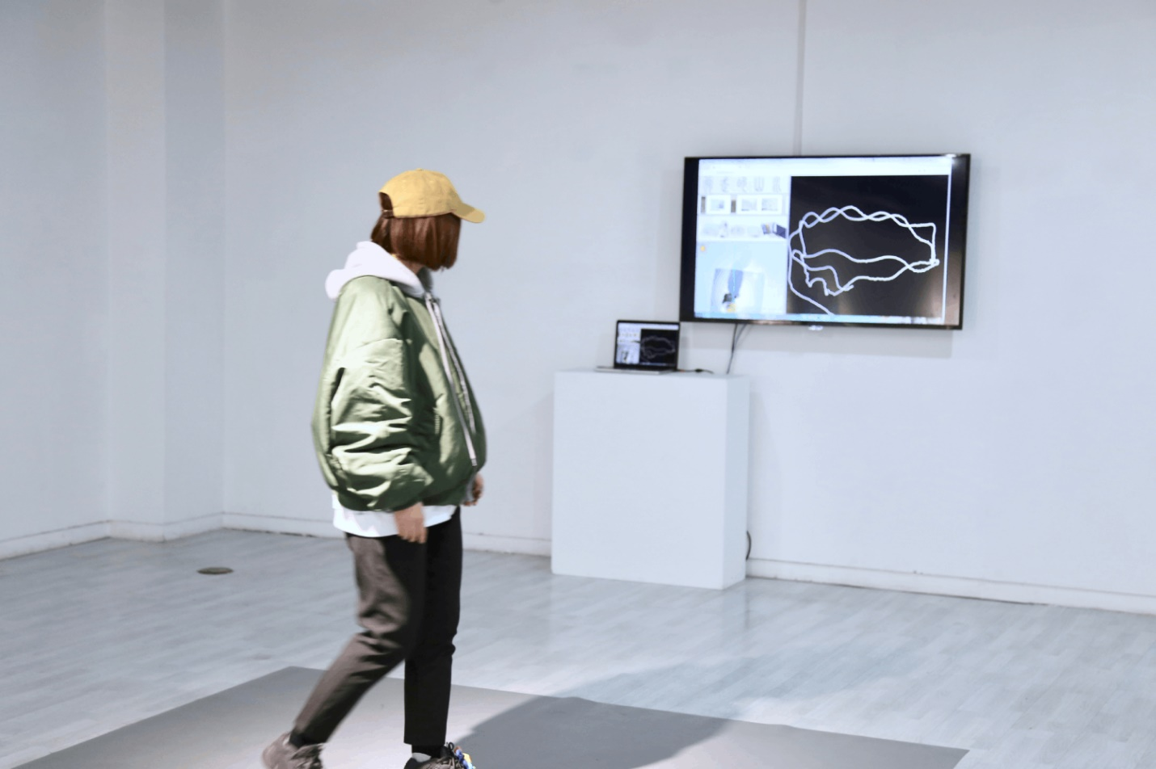

Aven Le Zhou

Walking Through Shanshui, (2019)

ICCV 2019, Seoul, Korea

Senior addressed five major paradigms for vision-based interactive artwork, and this project should belong to the projector-camera systems (37). These systems often capture the information from the camera of the people and provide feedback through the projector or screen (Senior, 39). Walking Through Shanshui capture the movement from people on the designed area by a camera system, and the movement is reflected on the screen in front of the viewers. As Levin described, detecting motion is one of the techniques in the computer vision system; the movement of people within the video frame can be detected by using frame differencing (469). I think this project was created by such a similar method to understand the difference of each frame of the real-time video and provide traces feedback on the screen.

Works Cited

“Computer Vision Art Gallery.” *Walking Through Shanshui*, computervisionart.com/pieces2019/walking-through-shanshui/.

Levin, Golan. "Computer vision for artists and designers: pedagogic tools and techniques for novice programmers." *AI & SOCIETY* 20.4 (2006): 462-482.

Senior, Andrew W., and Alejandro Jaimes. "Computer vision interfaces for interactive art." *Human-Centric Interfaces for Ambient Intelligence*. Academic Press, 2010. 33-48.